Installation Guide:

Installation steps for Anaconda distribution for Python for Windows

1. Download Anaconda from using the below URL for windows:

<https://www.anaconda.com/download/>

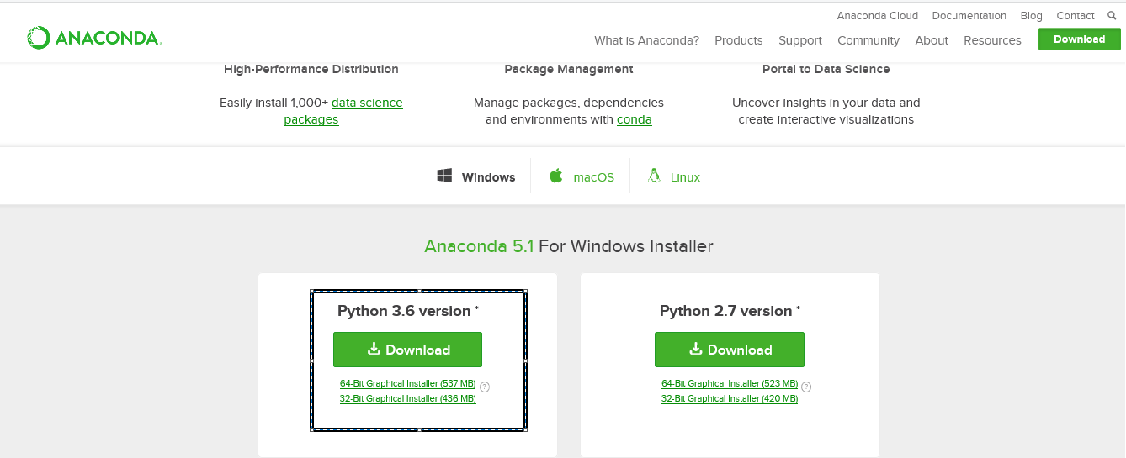



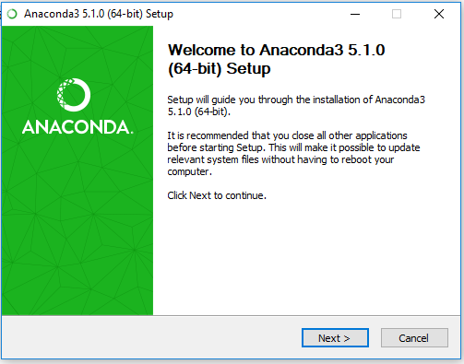

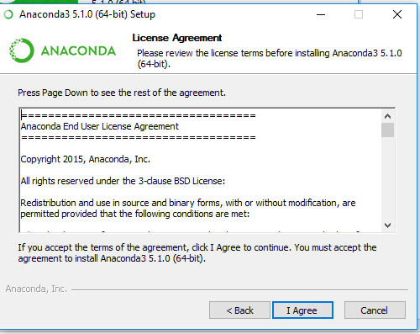

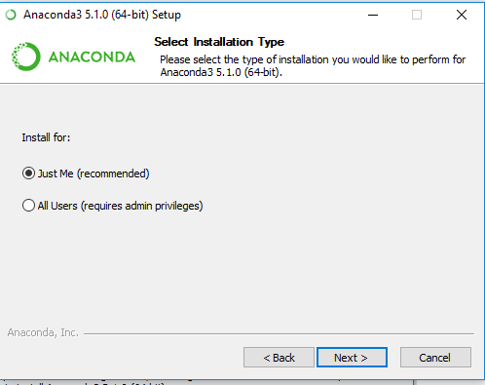

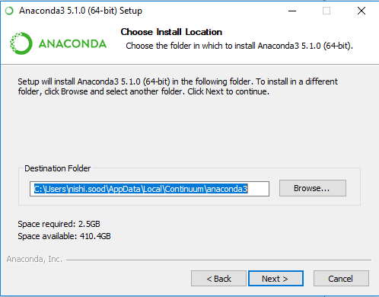

**NOTE :: Please click the below checkboxes before clicking NEXT.**

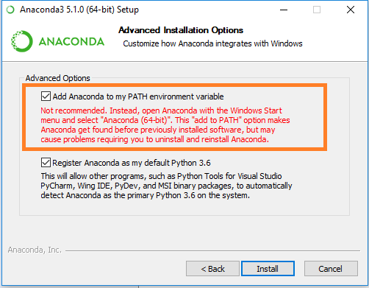

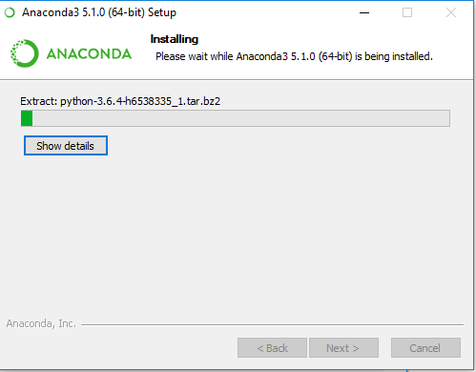

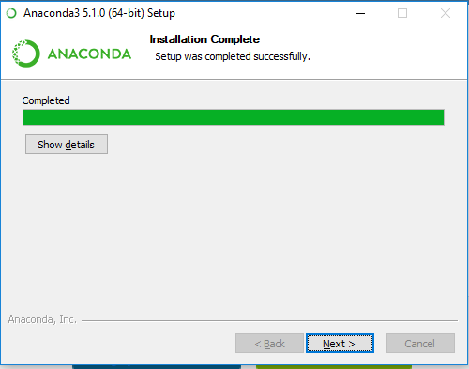



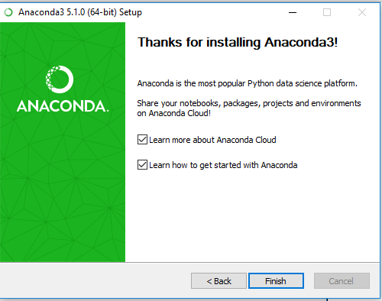

Steps to use the Jupyter Notebook from Anaconda Navigator after Anaconda installation:

1. Open Anaconda Navigator from the windows:

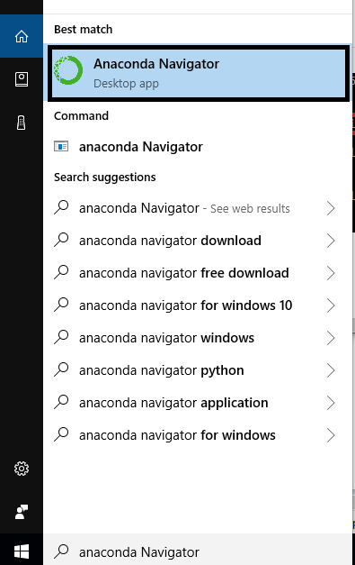

1. After some time the below screen will appear. Uncheck the checkbook and click OK.

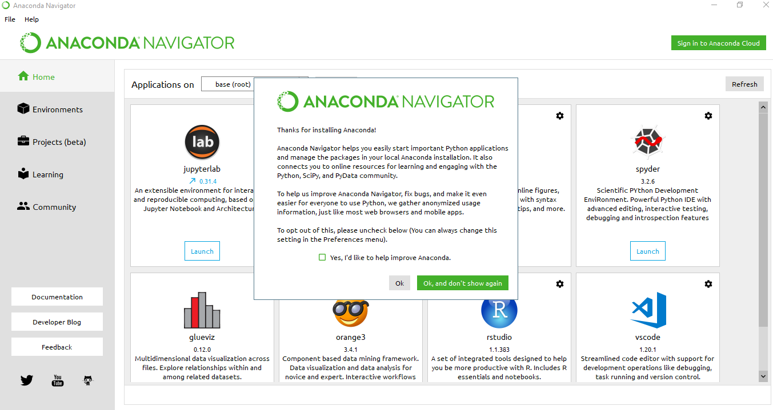

1. After opening the Anaconda Navigator, Click on Launch button of “Jupyter Notebook” and wait for some time for the “Jupyter notebook” to open in the browser as shown below:

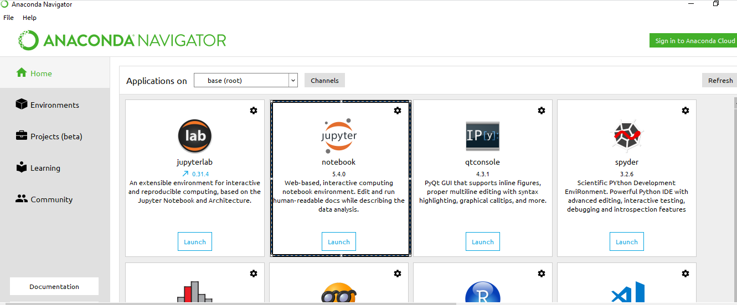

In future to open the “Jupyter notebook” directly type the below URL:

<http://localhost:8892/tree>

1. To open an already existing file use the “Upload option” and for creating a new file use the “New” option:

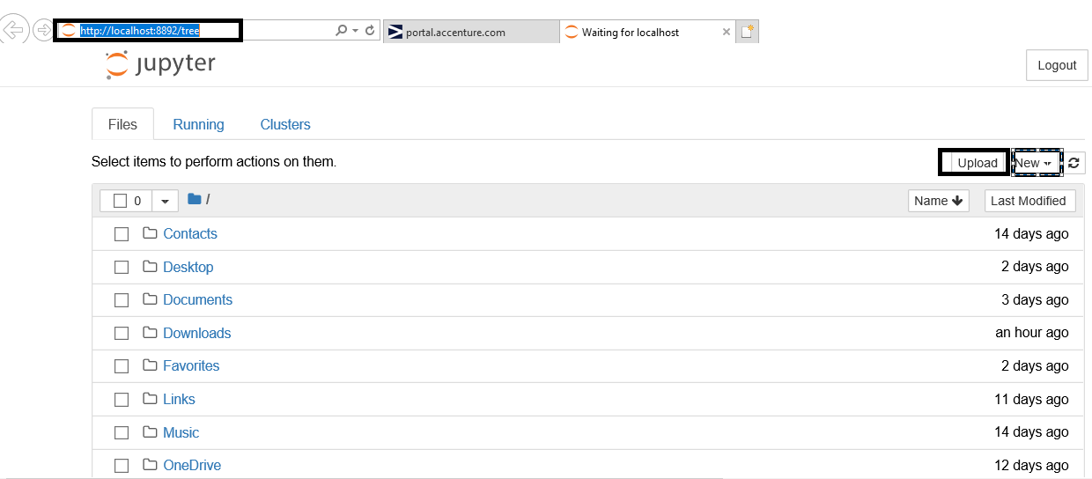

1. Steps to create a New Jupyter Notebook for Python3.

Click on the “New” button and select notebook as “Python 3” as shown below.

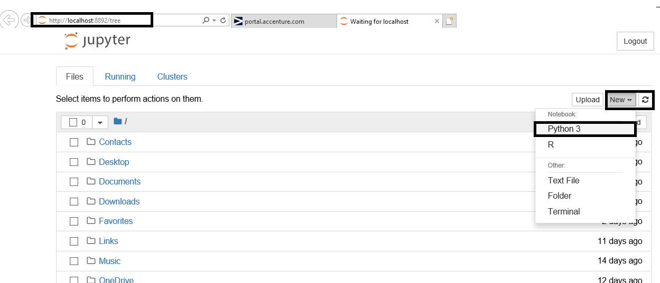

The below screen will appear. Practice some basics commands.

